Pirate Reference Image:

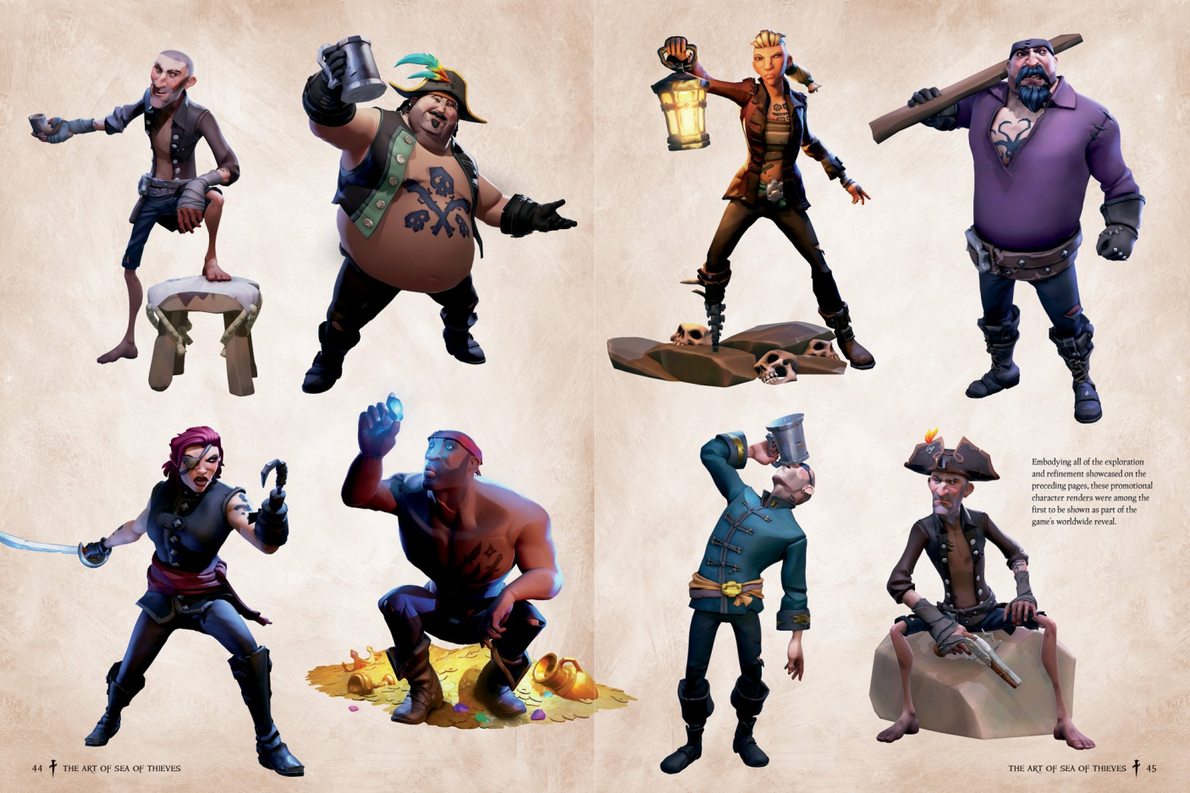

**Pirate’s Voice Lines (Rough, Finished):**

(sections based on tutorial description/gameplay loop/etc)

**1 Talk to Pirate (Letter Lagoon Backstory/Call to Action)**

**LG005**

* *“Ahoy there, ya salty dog! About time ye woke up. I take it from the bruisin’ on yer scalp and yer confused mug that ye don’t remember anythin’ -- we was on our ship, see? O, finest in the blue. Then the sea devils rose from the depths and attacked -- aye, she met her maker. Sadder than a dry barrel o’ rum. Don’t remember much else, but when I woke up, we was washed up ‘ere. Ye see the cave behind me? Well, I took a gander inside and found ancient letters linin’ the walls. Couldn’t tell what all o’ them was sayin’, but I could read enough. It said this: There be treasure chests buried on the islands surroundin’ us... containin’ golden letters -- treasures! They may be our way outta this doggone place, and I’ll need yer help to dig ‘em up. I also found a map, a rusty shovel, and a key -- ye’ll need all three to get the job done.”*

**2 Tutorial - Map**

**LG006**

* *“Put yer hands together and pull ‘em apart! Go on, do it my boy. This be your map. As ye can see… five islands is surroundin’ this grander land mass we’re on now. They be on all sides of us. When I ask ye to go dig me up a letter, pick the proper island and ye’ll be well on yer way!*

**3 Tutorial - Shovel**

**LG007**

* *“Aye, I already fixed the shovel onto yer side while ye was sleepin’! *Laughter* Go ahead, look down there at yer hip and grab what ye see. This here shovel, rusty as she be, oughta help ye dig up them buried letters. Swing ‘er ‘round a bit, get familiar with ‘er weight.*

**4 Tutorial - Key**

**LG008**

* *“Now, down by yer other side ye’ll see the key. Go ahead, get a feelin’ for it. When ye dig up them century old chests, ye’ll be usin’ this to get through their locks!*

**5 Tutorial - Enemy/Crab**

**LG009**

* *“Now, I’m ‘bout to tell ye o’ the sand devils plaguin’ these parts. Crabs. Them critters taste like heaven, aye, but they’s plottin’! They see the letters as belongin’ to them, and if ye dig in the wrong spot, they may try to steal ‘em back! If they do, be sure to chase ‘em down and hit ‘em with yer shovel!*

*LG010*

* *(if Player is then prompted to hit a crab that appears off to the side) “Ahoy, ye see that one over there? Go give ‘er a whackin’! Right on ‘er head!”*

**6 Talk to Pirate (First Time/First Letter Assignment)**

**LG011**

* *“Now that ye got yerself on yer feet, it’s about time to go fetch that first letter! *Laughter* And remember, we gotta be quick or else we’ll have to be startin’ all over again! Aye, the first letter ye’ll be goin’ after is *insert letter*!”*

**7 Talk to Pirate (Map Suggestion, Variations)**

**LG012**

* *“Remember, ye got yer map with ye!”*
* *“Yer map might be of help to ye right now.”*
* *“Aye, open yer map to find out where ye be goin’!”*

**8 Talk to Pirate (Island Suggestion, Variations for Different Islands)**

**LG013**

* *(island 1) “Ye may wanna be looking in the top left there, boyo!”*
* *(island 2) “Ye can always trust what’s up top n’ on the right… me father used to say that about maps.”*
* *(island 3) “It may be wise to put yer faith in the one on the right.”*
* *(island 4) “Aye, go ahead and look at the bottom o’ the map.”*
* *(island 5) “I got me a good feelin’ about the island on the left, there…”*

**9 Talk to Pirate (Correct Island Suggestion, Variations for Sake of Variety)**

**LG014**

* *“Yer on the right island! Quickly now, go get yer shovel in the ground.”*
* *“Aye, yer in the right place! Only thing left now is diggin’!”*
* *“Yes yes, ye done good. Now, just dig up that golden letter and we’ll be on our way…”*
* *“Ahoy, this be the right one! Now pick up yer shovel and start diggin’!”*

**10 Talk to Pirate (Wrong Island Suggestion)**

**LG015**

* *“I got a bad feelin’ about this island, boyo -- ye may be in the wrong spot.”*
* *“Aye, ye may wanna try another island…”*
* *“Somethin’ about this island seems fishy, best go try another one…”*
* *“Aye, this island don’t have the right letter, I know it be true -- go ahead, pull out yer map again.”*

**11 Talk to Pirate (Correct Dig Spot/Chest Speech)**

**LG016**

* *“Aye, ye done good, boyo! Go ahead, use yer key on the ol’ lock there! Ye done it! Ye got us the letter *insert letter*!*
* *Now then, the next one for ye to find is the letter *insert letter*.”*
* *“Thar she blows, my lad!!! Quick, get yer key and open ‘er up! *Laughter* By my portside cannon, can it be?*insert letter*! Great work! But there be no time to waste. Next up, the letter *insert letter*.”*
* *“Another victory for ye! Remember, use yer key to get ‘er open. There she is, the letter *insert letter*! Good, good. Movin’ right along, the next letter is *insert letter*.”*
* *“You’re doin’ fantastic, boyo! Just get this here lock open now, same as the others. Ahoy, it’s the letter *insert letter*! Now, the final letter for ye to be getting is *insert letter*.”*
* *“Goodness, lad! As long as ye can get this lock open, we’ll be goin’ full sails ahead! O, ye gone n’ found all five letters! Yer the finest treasure hunter in the ocean blue, yes, ye truly are. Go ahead n’ bring ‘em all back to me now.”*

**12 Talk to Pirate (Crab/After Hitting & Getting Letter Back)**

**LG017**

* *“O merciful seaweed, there be a crab! He’s taken one o’ yer letters! Quick, give him chase! Hit him over the head with yer shovel! Okay good, ye saved the letter -- but now ye need to move quicker!”*
* *“A crab! Scurvy incarnate, he’s stolen one o’ yer letters! Quick, go whack him with yer shovel n’ get back what’s yers! Good job retrievin’ what’s yers, but I still need the letter *insert letter*! Hurry, the clock be tickin’!”*
* *“No no, it’s a crab! He’s taken a letter from ye! Don’t let him get away! Use yer shovel to stop him! Aye, good job, but ye need to be movin’ that quick to get me the letter *insert letter*!”*
* *“O curses, the sand devils be out to play! No, he’s stolen a letter from ye! Chase him down, hit him with yer shovel! Wonderful work, but now it’s time to stop yer lollygaggin’ n’ find the letter *insert letter*.”*

**13Talk to Pirate (Returning All Letters/Transition to Case Matching Cave)**

**LG018**

* *“O, look at ye, back with a true sailor’s haul! Ye done great, kiddo -- that be true. As soon as we get outta here, the world is sure to know. Now, no time to be wastin’ -- come with me into the darkness o’ the cave and we’ll see what greater mysteries lie in store...”*